LAB-1
Question 1
Create a NumPy array containing the integers from 1 to 20. Perform the following operations:
1. Display the array.
2. Find the shape of the array.
3. Find the maximum and minimum values.
4. Calculate the mean and standard deviation.
5. Reshape the array into a 4 × 5 matrix.
6. Display the second row of the matrix.
7. Display the third column of the matrix.

CODE:
import numpy as np
arr = np.arange(1,21)
print("Original Array")
print(arr)
print(arr.shape)
print(arr.max())
print(arr.min())
print(arr.mean())
print(arr.std())
matrix=arr.reshape(4,5)
print(matrix)
print(matrix[1])
print(matrix[:,2])
OUTPUT:
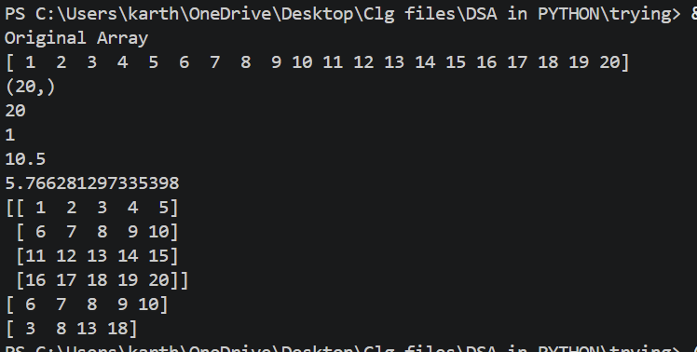

Question 2
Create two NumPy arrays: A = [10, 20, 30, 40, 50] B = [5, 10, 15, 20, 25] Perform:
1. Addition of A and B.
2. Subtraction of B from A.
3. Element-wise multiplication.
4. Element-wise division.
5. Find the sum of all elements in A.

CODE:
import numpy as np
A = np.array([10,20,30,40,50])
B = np.array([5,10,15,20,25])
print(A)
print(B)
print(A+B)
print(A-B)
print(A*B)
print(A/B)
print(A.sum())

OUTPUT:
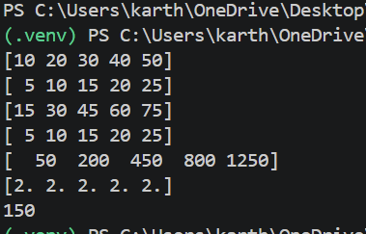

Question 3
Create a DataFrame using the following student data:
Roll No Name Marks
101 Ravi 85
102 Priya 92
103 Kiran 78
104 Anu 88
105 Sita 95
Perform the following operations:
1. Display the DataFrame.
2. Display the first three records.
3. Find the average marks.
4. Find the student with the highest marks.
5. Find the student with the lowest marks.
6. Add a new column called "Grade" using:
o A for Marks ≥ 90 o B for Marks between 80 and 89
o C for Marks < 80
CODE:
import pandas as pd
data = {
'Roll No': [101,102,103,104,105],
'Name':['Ravi', 'Priya','Kiran','Anu','Sita'],
'Marks':[85,92,78,88,95]}
dt=pd.DataFrame(data)
print(dt)
print(dt.head(3))
print(dt['Marks'].mean())
highest_marks=(dt.loc[dt['Marks'].idxmax()])['Name']
print(highest_marks)
lowest_marks=(dt.loc[dt['Marks'].idxmin()])['Name']
print(lowest_marks)
def assign_grade(marks):
if marks >=90:
return 'A'
elif 80<= marks<= 90:
return 'B'
else:
return 'C'
dt['Grade']=dt['Marks'].apply(assign_grade)
print(dt)
OUTPUT:
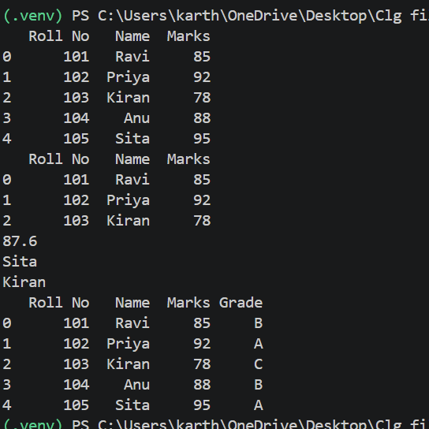

Question 4
Create a DataFrame containing the following information:
Product Price Quantity
Laptop 50000 10
Mouse 500 50
Keyboard 1200 30
Monitor 10000 15
Perform:
1. Calculate the total value of each product using: Total Value = Price × Quantity
2. Add the Total Value column.
3. Find the product with the highest total value.
4. Calculate the overall inventory value.
CODE:
import pandas as pd
data = {'Product': ['Laptop',"Mouse","Keyboard","Monitor"],
'Price':[50000,500,1200,10000],
'Quantity':[10,50,30,15]}
df=pd.DataFrame(data)
print(df)
df['Total Value'] = df['Price'] * df['Quantity']
print("1 & 2. Updated DataFrame with 'Total Value':")
print(df)
highest_val_product = df.loc[df['Total Value'].idxmax(), 'Product']
print(f"3. Product with the highest total value: {highest_val_product}")
overall_value = df['Total Value'].sum()
print(f"4. Overall inventory value: Rs. {overall_value:,}")
OUTPUT:
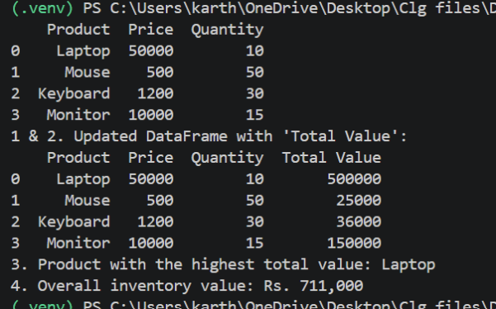

Question 5
Download the Iris dataset from Scikit-learn and perform the following:
1. Load the dataset into a Pandas DataFrame.
2. Display the first five records.
3. Find the number of rows and columns.
4. Display column names.
5. Check for missing values.
6. Generate summary statistics using describe().
7. Find the number of samples belonging to each class.

CODE:
import pandas as pd
from sklearn.datasets import load_iris
iris = load_iris()
df = pd.DataFrame(data=iris.data, columns=iris.feature_names)
df['species'] = iris.target
species_map = {i: name for i, name in enumerate(iris.target_names)}
df['species'] = df['species'].map(species_map)
print("2. First five records:")
print(df.head())
print("\n" + "="*50 + "\n")
rows, cols = df.shape
print(f"3. Number of Rows: {rows}")
print(f" Number of Columns: {cols}")
print("\n" + "="*50 + "\n")
print("4. Column names:")
print(list(df.columns))
print("\n" + "="*50 + "\n")
print("5. Missing values per column:")
print(df.isnull().sum())
print("\n" + "="*50 + "\n")
print("6. Summary statistics:")
print(df.describe())
print("\n" + "="*50 + "\n")
print("7. Number of samples per class:")
print(df['species'].value_counts())

OUTPUT:
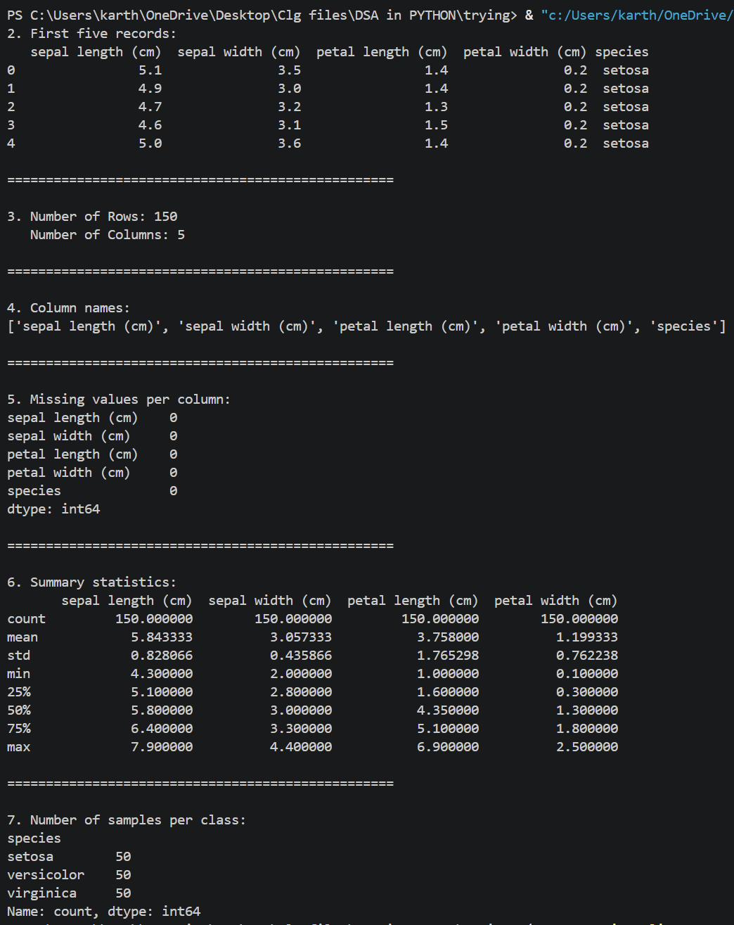

LAB-2
Question:
Aim:
To perform exploratory data analysis (EDA) on a student performance dataset using Pandas and Matplotlib.
Dataset:
Create a CSV file named student_data.csv with the following data:
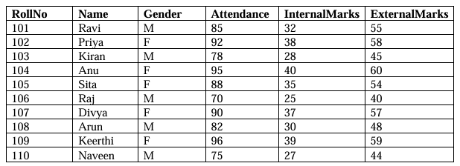
Tasks:
Task A: Dataset Loading and Inspection
. Import the necessary Python libraries.
. Load the dataset into a Pandas DataFrame.
. Display the first five records.
. Display the last five records.
. Find the total number of rows and columns.
. Display the names of all columns.
. Display the data type of each column.
· Generate dataset information using info().

Task B: Statistical Analysis
. Calculate the mean attendance of all students.
. Calculate the average Internal Marks.
. Calculate the average External Marks.
. Find the maximum Internal Marks.
. Find the minimum Internal Marks.
. Find the maximum External Marks.
. Find the minimum External Marks.
. Calculate the standard deviation of Internal Marks.
. Generate summary statistics using describe().
Task C: Data Manipulation
. Create a new column named TotalMarks.
. TotalMarks=InternalMarks+ExternalMarks
. Create a new column named Percentage.
1. Percentage=TotalMarks/100x100
. Display the updated DataFrame.

Task D: Filtering and Searching
. Display the details of students whose attendance is greater than 90%.
. Display the details of students whose TotalMarks exceed 90.
. Display the details of female students.
. Display the details of male students.
. Display students whose ExternalMarks are less than 50.

Task E: Ranking and Comparison
. Identify the student with the highest TotalMarks.
. Identify the student with the lowest TotalMarks.
. Display the top three performers based on TotalMarks.
. Display the bottom three performers based on TotalMarks.
. Determine how many students scored above the class average.

Task F: Group-wise Analysis
. Calculate the average TotalMarks of male students.
. Calculate the average TotalMarks of female students.
. Compare the average attendance of male and female students.

Task G: Data Visualization
. Plot a bar chart showing TotalMarks of all students.
. Plot a histogram of Attendance.
. Plot a pie chart showing the distribution of male and female students.
. Plot a scatter plot between Attendance and TotalMarks.
. Interpret the relationship between Attendance and TotalMarks.

Task H: Observations
. Write any three observations based on the analysis performed.
. State whether higher attendance appears to be associated with better academic
performance.

CODE:
import pandas as pd
import matplotlib.pyplot as plt
# Task A: Dataset Loading and Inspection
print("--- Task A: Dataset Loading and Inspection ---")
df = pd.read_csv('student_data.csv')
print("\nFirst 5 Records:")
print(df.head(5))
print("\nLast 5 Records:")
print(df.tail(5))
print(f"\nTotal rows and columns: {df.shape}")
print(f"Column Names: {list(df.columns)}")
print("\nData Types:")
print(df.dtypes)
print("\nDataset Info:")
df.info()
# Task B: Statistical Analysis
print("\n--- Task B: Statistical Analysis ---")
print(f"Mean Attendance: {df['Attendance'].mean():.2f}%")
print(f"Average Internal Marks: {df['InternalMarks'].mean():.2f}")
print(f"Average External Marks: {df['ExternalMarks'].mean():.2f}")
print(f"Maximum Internal Marks: {df['InternalMarks'].max()}")
print(f"Minimum Internal Marks: {df['InternalMarks'].min()}")
print(f"Maximum External Marks: {df['ExternalMarks'].max()}")
print(f"Minimum External Marks: {df['ExternalMarks'].min()}")
print(f"Standard Deviation of Internal Marks: {df['InternalMarks'].std():.2f}")
print("\nSummary Statistics Using describe():")
print(df.describe())
# Task C: Data Manipulation
print("\n--- Task C: Data Manipulation ---")
df['TotalMarks'] = df['InternalMarks'] + df['ExternalMarks']
df['Percentage'] = (df['TotalMarks'] / 100) * 100
print("\nUpdated DataFrame:")
print(df)
# Task D: Filtering and Searching
print("\n--- Task D: Filtering and Searching ---")
print("\nStudents with Attendance > 90%:")
print(df[df['Attendance'] > 90])
print("\nStudents with Total Marks > 90:")
print(df[df['TotalMarks'] > 90])
print("\nFemale Students:")
print(df[df['Gender'] == 'F'])
print("\nMale Students:")
print(df[df['Gender'] == 'M'])
print("\nStudents with External Marks < 50:")
print(df[df['ExternalMarks'] < 50])
# Task E: Ranking and Comparison
print("\n--- Task E: Ranking and Comparison ---")
highest_idx = df['TotalMarks'].idxmax()
lowest_idx = df['TotalMarks'].idxmin()
print(f"Student with Highest TotalMarks: {df.loc[highest_idx, 'Name']} ({df.loc[highest_idx, 'TotalMarks']})")
print(f"Student with Lowest TotalMarks: {df.loc[lowest_idx, 'Name']} ({df.loc[lowest_idx, 'TotalMarks']})")
print("\nTop 3 Performers:")
print(df.nlargest(3, 'TotalMarks')[['Name', 'TotalMarks']])
print("\nBottom 3 Performers:")
print(df.nsmallest(3, 'TotalMarks')[['Name', 'TotalMarks']])
class_avg_total = df['TotalMarks'].mean()
above_avg_count = df[df['TotalMarks'] > class_avg_total].shape[0]
print(f"\nNumber of students scoring above class average ({class_avg_total:.2f}): {above_avg_count}")
# Task F: Group-wise Analysis
print("\n--- Task F: Group-wise Analysis ---")
grouped = df.groupby('Gender').mean(numeric_only=True)
print(f"Average TotalMarks of Male Students: {grouped.loc['M', 'TotalMarks']:.2f}")
print(f"Average TotalMarks of Female Students: {grouped.loc['F', 'TotalMarks']:.2f}")
print(f"Average Attendance - Male: {grouped.loc['M', 'Attendance']:.2f}%, Female: {grouped.loc['F', 'Attendance']:.2f}%")
# Task G: Data Visualization
# 1. Bar Chart: Total Marks
plt.figure(figsize=(8, 5))
plt.bar(df['Name'], df['TotalMarks'], color='skyblue', edgecolor='black')
plt.title('Total Marks of All Students')
plt.xlabel('Student Name')
plt.ylabel('Total Marks')
plt.grid(axis='y', linestyle='--', alpha=0.7)
plt.show()
# 2. Histogram: Attendance
plt.figure(figsize=(8, 5))
plt.hist(df['Attendance'], bins=5, color='lightgreen', edgecolor='black')
plt.title('Distribution of Attendance')
plt.xlabel('Attendance (%)')
plt.ylabel('Number of Students')
plt.show()
# 3. Pie Chart: Gender Distribution
plt.figure(figsize=(6, 6))
gender_counts = df['Gender'].value_counts()
plt.pie(gender_counts, labels=gender_counts.index, autopct='%1.1f%%', colors=['lightcoral', 'dodgerblue'], startangle=140)
plt.title('Gender Distribution')
plt.show()
# 4. Scatter Plot: Attendance vs Total Marks
plt.figure(figsize=(8, 5))
plt.scatter(df['Attendance'], df['TotalMarks'], color='purple', s=100, edgecolor='black')
plt.title('Attendance vs Total Marks')
plt.xlabel('Attendance (%)')
plt.ylabel('Total Marks')
plt.grid(True, linestyle='--', alpha=0.5)
plt.show()
OUTPUT:
